Qualifying Examination in Topology (January 12, 2005)

Directions
Work all the problems. They are weighted evenly.

Problems
- Suppose $X$ is a compact metric space and $U$ is an open covering of $X$. Prove that there is a number $δ>0$ so that for every $x∈X$, the ball of radius $δ$ centered at $x$ is contained in some element of $U$.
- Prove that a connected normal space with more than a single point must be uncountable.
- Suppose $f:X→Y$ is a function, and let $G=\{(x,f(x)):x∈X\}⊂X×Y$.
  - Prove that if $Y$ is Hausdorff and $f$ is continuous, then $G$ is closed.
  - Prove that if $Y$ is compact and $G$ is closed, then $f$ is continuous. (Hint: Start by proving that the projection $p:X×Y→X$ is a closed map.)
- Let $X$ be the topological space formed by filling in two disks in the torus, as shown. Calculate $H_{*}(X,Z)$ by any method you wish.
- 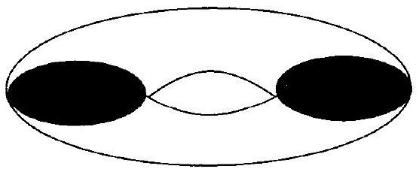
- Let $X$ be the topological space formed by identifying the edges of a pentagon, as shown.
- 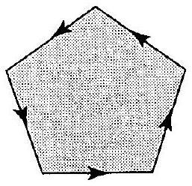
- Calculate $π_{1}(X)$ and give the universal covering space of $X$.

  - Suppose $Y$ is an $n$-fold covering space of the (one-holed) torus. What is $Y$? Justify your answer.
  - Let $X$ be the topological space formed by deleting a disk from a torus, as shown.
  - 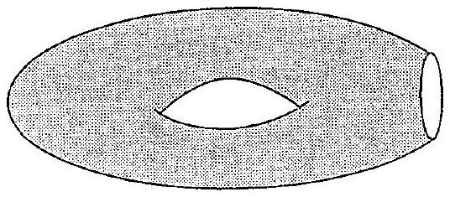
  - Suppose $Y$ is a 3-fold covering space of $X$. What surfaces could $Y$ be? Justify your answer, but you need not exhibit the covering maps explicitly.
- Let $n≥2$. Prove that the covering map $π:S^{n}→RP^{n}$ is not nullhomotopic.
- Define a linear map $R^{2}→R^{2}$ by the matrix
$$A=\left[\begin{matrix}1 & -1 \\ 1 & 2\end{matrix}\right].$$
- Let $T^{2}=R^{2}/Z^{2}$ be endowed with the quotient topology.
  - Prove that $A$ induces a well-defined, continuous map $f:T^{2}→T^{2}$.
  - Suppose $g:T^{2}→T^{2}$ is a continuous map that is homotopic to $f$. Prove or disprove: $g$ has a fixed point.
- Do one of the following.
  - Give (with justification) a contractible subset $X⊂R^{2}$ that is not a retract of $R^{2}$.
  - Give (with justification) two topological spaces that have the same homology groups but that are not homotopy equivalent.

